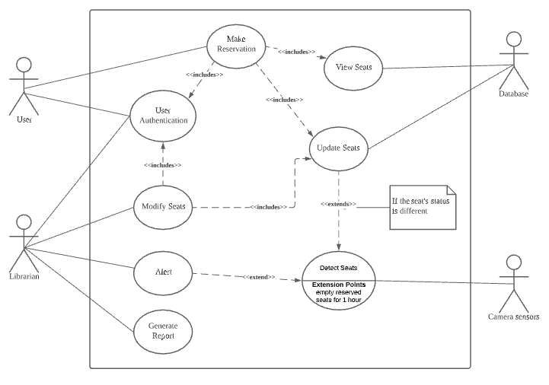

**SmartLib**

**Use Case Description**

|  |  |  |  |
| --- | --- | --- | --- |
| Use Case ID: | 1 | | |
| Use Case Name: | ViewSeats | | |
| Created By: | Kenny | Last Updated By: |  |
| Date Created: | 28/1/21 | Date Last Updated: |  |

|  |  |
| --- | --- |
| Actor: | User, Librarian, database |
| Description: | The user/librarian can check the status of the seats in the library. The status of each seat will be displayed in different colours. |
| Preconditions: | 1. The device must be connected to the internet. 2. The application must be able to retrieve data from the database |
| Postconditions: | 1. The status of each seat in the library is displayed on screen. |
| Priority: | High. |
| Frequency of Use: | Two times a day. |
| Flow of Events: | 1. The user/ librarian presses on the screen to start the application. 2. The map of the library with the status of each seat will be shown on the screen. 3. The status of each seat is retrieved from the database. 4. The status of the seats will be displayed in either red (occupied) , orange (reserved ) and green (empty). 5. By default, the ground floor of the library will be displayed but user/ librarian can check on different floors by selecting the floor level. |
| Alternative Flows: | NiL |
| Exceptions: | NIL |
| Includes: | Nil |
| Special Requirements: | The application must be able to show the status of the seats in real time. |
| Assumptions: | NIL |
| Notes and Issues: | NIL |

|  |  |  |  |
| --- | --- | --- | --- |
| Use Case ID: | 2 | | |
| Use Case Name: | MakeReservation | | |
| Created By: | Kenny | Last Updated By: | Kenny |
| Date Created: | 28/1/21 | Date Last Updated: | 29/1/21 |

|  |  |
| --- | --- |
| Actor: | User |
| Description: | The user can reserve an empty seat for 15 minutes. |
| Preconditions: | 1. The user signed into his/her account 2. The user views and chooses the empty seat shown on the map of the library |
| Postconditions: | 1. The seat is reserved for 15 minutes |
| Priority: | High. |
| Frequency of Use: | Two times a day. |
| Flow of Events: | 1. The user uses the included use case UserAuthentication to sign into his/her account. 2. The user uses the included use case ViewSeat to find an empty seat in the library. 3. The user clicks on the empty seat. 4. After confirmation from the user, the status of the seat is updated in the included use case UpdateSeats and the seat will be reserved for 10 minutes |
| Alternative Flows: | Nil |
| Exceptions: | EX1 : The user didn’t go to the seat after 10 minutes   1. The reservation will be canceled |
| Includes: | ViewSeats ,UserAuthentication, UpdateSeats |
| Special Requirements: | Nil |
| Assumptions: | Nil |
| Notes and Issues: | NIL |

|  |  |  |  |
| --- | --- | --- | --- |
| Use Case ID: | 3 | | |
| Use Case Name: | DetectSeats | | |
| Created By: | Kenny | Last Updated By: |  |
| Date Created: | 28/1/21 | Date Last Updated: | 1/2/21 |

|  |  |
| --- | --- |
| Actor: | Camera |
| Description: | The camera will capture the photo of the seats and send it to the application. The application will use a deep learning model to check the status of the seats and update the status to the database via wifi. |
| Preconditions: | 1. The application received the photo from the camera. |
| Postconditions: | 1. The status of each seat is detected and updated if there’s changes. |
| Priority: | High |
| Frequency of Use: | multiple times a day. |
| Flow of Events: | 1. The camera will capture the photo every 3 seconds and send it to the application. 2. The application uses Convolutional Neural Network model and algorithm to detect whether the status of each seat with the photo taken. 3. The status of the seats that are occupied by users is “Occupied” while the seats that are chopped with items such as bags or books is “Chopped” and the status of the seats that are empty is “Empty” 4. If there’s changes in the status of the seats, the status will be updated in the included use case UpdateSeats. |
| Alternative Flows: | AF-S4: No changes in the status of the seats   1. No action |
| Exceptions: | NiL |
| Includes: | UpdateSeats |
| Special Requirements: | Nil |
| Assumptions: | Nil |
| Notes and Issues: | NIL |

|  |  |  |  |
| --- | --- | --- | --- |
| Use Case ID: | 4 | | |
| Use Case Name: | UpdateSeats | | |
| Created By: | Kenny | Last Updated By: | Kenny |
| Date Created: | 28/1/21 | Date Last Updated: | 1/2/21 |

|  |  |
| --- | --- |
| Actor: | Database |
| Description: | The application will update the status or add/remove seats to the database. |
| Preconditions: | 1. The new status of the seat is received. 2. The application is connected to the database |
| Postconditions: | 1. The status of the seats will be updated to the database |
| Priority: | Medium |
| Frequency of Use: | multiple times a day. |
| Flow of Events: | 1. The new status of seat is received 2. The application will update the status to the database. |
| Alternative Flows: | AF-S1: Librarian add/remove seats   1. Seat will be added/remove from the database |
| Exceptions: | NiL |
| Includes: | Nil |
| Special Requirements: | Nil |
| Assumptions: | Nil |
| Notes and Issues: | NIL |

|  |  |  |  |
| --- | --- | --- | --- |
| Use Case ID: | 5 | | |
| Use Case Name: | Alert | | |
| Created By: | Kenny | Last Updated By: |  |
| Date Created: | 28/1/21 | Date Last Updated: |  |

|  |  |
| --- | --- |
| Actor: | Librarian |
| Description: | The application will alert the librarian if there's a seat that is chopped with items for more than 1 hour. |
| Preconditions: | 1. The status of the seats is checked in use case DetectSeats |
| Postconditions: | 1. Alert the librarian |
| Priority: | Low |
| Frequency of Use: | Few times a day. |
| Flow of Events: | 1. The application provides the status of the seat from the included use case DetectSeats. 2. If the status of a seat is “Occupied” for more than 1 hour, the application alerts the librarian of the chopped seats. |
| Alternative Flows: | Nil |
| Exceptions: | Nil |
| Includes: | DetectSeats |
| Special Requirements: | Nil |
| Assumptions: | Nil |
| Notes and Issues: | NIL |

|  |  |  |  |
| --- | --- | --- | --- |
| Use Case ID: | 6 | | |
| Use Case Name: | UserAuthentication | | |
| Created By: | Kenny | Last Updated By: |  |
| Date Created: | 29/1/21 | Date Last Updated: |  |

|  |  |
| --- | --- |
| Actor: | User, Librarian |
| Description: | The user/ librarian can sign into students or admin account to perform specific task such as reserve seat |
| Preconditions: | 1. SmartLib is connected to internet |
| Postconditions: | 1. The user/librarian signed into their account |
| Priority: | Medium |
| Frequency of Use: | Multiple times a day. |
| Flow of Events: | 1. User/librarian press on the login button 2. System ask for user and password 3. User/librarian enter his credential 4. If the credential is validated, it will display menu of options |
| Alternative Flows: | AF-S3: Failed to login   1. The system will display “Wrong user/password “ 2. Return to step 2 |
| Exceptions: | Nil |
| Includes: | Nil |
| Special Requirements: | Nil |
| Assumptions: | Nil |
| Notes and Issues: | NIL |

|  |  |  |  |
| --- | --- | --- | --- |
| Use Case ID: | 7 | | |
| Use Case Name: | ModifySeats | | |
| Created By: | Kenny | Last Updated By: |  |
| Date Created: | 29/1/21 | Date Last Updated: |  |

|  |  |
| --- | --- |
| Actor: | Librarian |
| Description: | The librarian is able to add/remove and temporarily grey out seats |
| Preconditions: | 1. SmartLib is connected to internet 2. Librarian signed into the admin account |
| Postconditions: | 1. The seats in the library is updated |
| Priority: | Low |
| Frequency of Use: | 1 times a day. |
| Flow of Events: | 1. The librarian uses the included use case UserAuthentication to sign into the admin account. 2. The librarian can add remove and temporarily grey out seats |
| Alternative Flows: | Nil |
| Exceptions: | Nil |
| Includes: | Nil |
| Special Requirements: | Nil |
| Assumptions: | Nil |
| Notes and Issues: | NIL |

|  |  |  |  |
| --- | --- | --- | --- |
| Use Case ID: | 8 | | |
| Use Case Name: | GenerateReport | | |
| Created By: | Kenny | Last Updated By: |  |
| Date Created: | 29/1/21 | Date Last Updated: |  |

|  |  |
| --- | --- |
| Actor: | Librarian |
| Description: | The librarian is able produce the report to show the statistics of seat occupancy in library |
| Preconditions: | 1. SmartLib is connected to internet 2. Librarian signed into the admin account |
| Postconditions: | 1. The required report is generated |
| Priority: | Low |
| Frequency of Use: | 1 times a day. |
| Flow of Events: | 1. The librarian uses the included use case UserAuthentication to sign into the admin account. 2. The librarian presses the “Generate Report “ button. 3. The report is generated |
| Alternative Flows: | Nil |
| Exceptions: | Nil |
| Includes: | UserAuthentication |
| Special Requirements: | Nil |
| Assumptions: | Nil |
| Notes and Issues: | NIL |